Contents
Overview 2
Icon Transparency 2
Icon Sizes 2
Large Icons 3
Icon Colors 3
Base RGB Values 3
VBA Macro Example Code 4
Source 4

Overview
Alphacam 2010 R1 brings an all new set of toolbar button and menu item icons. With this comes an enhancement which allows VBA, C++, or Delphi created add-ins to implement high color 32 Bit Alpha Bitmap images in both small (16x16) and large (32x32) sizes. This document contains information on how to take advantage of these enhancements.

Icon Transparency
In versions of Alphacam prior to 2010 R1, icon transparency was achieved by using the light gray color (R192 G192 B192). This will work in version 2010 R1 as well, but in addition, transparency can now be achieved by utilizing 32 Bit Alpha Bmp images (RGB/A).

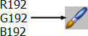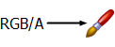

Not all graphic applications display Alpha Bitmaps correctly. For example, if you preview one using Windows Explorer, or open one using Microsoft Paint, the Alpha channel is always displayed in black.

Example…



A recommended application for creating and editing Alpha Bitmap images is IconWorkshop from Axialis (http://www.axialis.com/iconworkshop).

Icon Sizes
In versions of Alphacam prior to 2010 R1, icon images were expected to be 16 pixels wide by 15 pixels tall. These images will continue to work in 2010 R1, but ideally, icon images should now be 16 pixels wide by 16 pixels tall. In addition to the standard 16x16 icons, large 32x32 size buttons can be implemented as well.

Pre 2010 R1… 2010 R1…

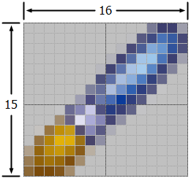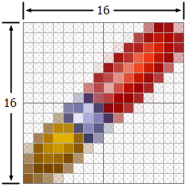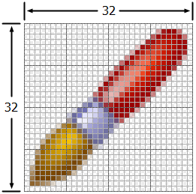

Large Icons
To implement large icons, nothing needs to be done within code. The Frame.AddButton method will automatically look for a corresponding .bmp which contains "Large" at the end of its file name. This file must be located in the same folder as the file being specified in the BmpFileName argument (See VBA Macro Example Code).

Large icons can be displayed via the Large Icons option with the toolbar customization dialog. To access this, right-click on any toolbar, click Customize, then go to the Options tab.

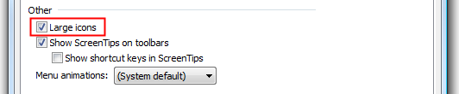

Icon Colors
Although there are exceptions, the color conventions below are generally used within the icon images.

- White/Gray usually represents “passive” or original objects (e.g. Geometry).
- Red usually represents something that is created by the command. Red arrows can also represent motion.
- Yellow/Gold usually represents the resulting object. Yellow/Gold also indicates points on an object.

Examples...

Icon | Command | Color Representations
 | Move | White/Grey indicates the original (to be moved) object  Red arrow indicates the object moving from one location to another  Yellow/Gold indicates the resulting (moved) object
 | Fillet | Red indicates the resulting radius
 | 3D Surface Machining | Red indicates the machined surface
 | Circle – 2 Points | Yellow/Gold squares indicate the two points on the circle

Base RGB Values
Color | Red | Green | Blue
Red | 180 | 48 | 45
Yellow | 255 | 222 | 91
Gold | 153 | 102 | 0
Grey | 153 | 154 | 154

VBA Macro Example Code
The example code below demonstrates how to implement toolbar buttons. This code, along with the full macro and buttons images, can be found in the ExampleFiles\API 2010\Buttons folder on the Alphacam install disc.

The example macro will add a new 2010 VBA Button Example menu and toolbar, using R192 G192 B192 and RGB/A images.

Menu | 16x16 Buttons | 32x32 Buttons
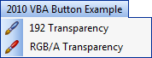 | 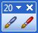 | 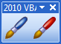

Source
Option Explicit

Function InitAlphacamAddIn(AcamVersion As Long) As Integer

Dim lngTB As Long

Const DEF_MENU As String = "2010 VBA Button Example"

With App.Frame

' create a new toolbar
lngTB = .CreateButtonBar(DEF_MENU)

' add a new menu and menu item using a 192/192/192 transparency image
If .AddMenuItem2("192 Transparency", "g_192", acamMenuNEW, DEF_MENU) Then

' Add the button. For this example, if a "192Large.bmp" file is found
' in the same folder as the "192.bmp", it will added automatically.
Call .AddButton(lngTB, "192.bmp", .LastMenuCommandID)

End If

' do the same as above, this time using a 32-bit Alpha Bitmap image
If .AddMenuItem2("RGB/A Transparency", "g_RGBA", acamMenuNEW, DEF_MENU) Then
Call .AddButton(lngTB, "RGBA.bmp", .LastMenuCommandID)
End If

End With

InitAlphacamAddIn = 0

End Function

Public Function g_ButtonTestRGBA()
MsgBox "RGB/A transparency", vbInformation
End Function

Public Function g_ButtonTest192()
MsgBox "R192 G192 B192 transparency", vbInformation
End Function

